**SET- A (EVEN ROLL NUMBER)**

1. Open the workbook named as ‘movies’, and create a pivot chart based upon the data showing the average number of Oscar nominations by certificate for any given genre in the new sheet:

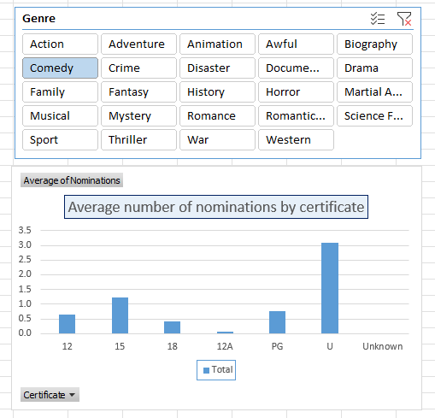

* Also Create a pivot table to show the total budget of each country according to the genre.

1. Open the workbook named as ‘Playground Safety Checks’ and use this to show the number of sites needing safety checks by the date when the next check is due:

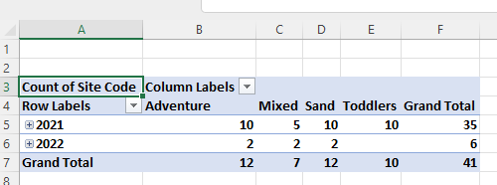

Change lots of formatting to get this:

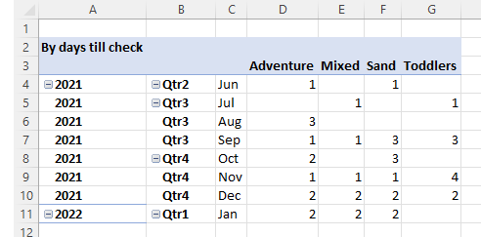

Add in a timeline to show data by the date when the last check was due, and use this to show just the first two quarters of 2021:

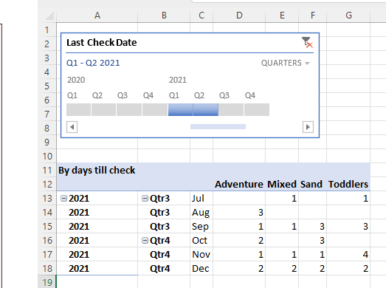

* Create a sunburst chart to show the sum of data month wise in each quarter.

1. Create one more pivot table to show the total number of swings, slides and Rocker for each site type

* Also create a pie chart to represent the above table in a graphical manner and highlight the site type having the total maximum value as a separate slice.